Dear Friends of the Jewish Museum in Vilnius/Vilne,
5769 Shana Tova! Mazl Tov!
We are happy to have the opportunity to talk to you today, at the eve of Rosh ha Shana and congratulate you with this Holy day.
We are also happy to share with you our joy for having got new Friends, like Edward Cowan (USA), David Natman (USA), Janine Cohen (USA), Karen Smith (UK), Carol Kaplan (USA), Deborah Allen (USA), Anthon Schneider (USA), Alan and Janice Seder (USA), Samuel Josefowitz (CH), Barry Winkleman (UK), among them
We are happy to say that we got support from a number of wonderful people, like Karen Smith (UK), Janine Cohen (USA), Carol Kaplan (USA), Leona Z. Rosenberg (USA), Mr Keith Kaye (USA),Dan and Phil Shapiro (USA), Gordon Schochet (USA), Wyman Brent (USA), Sir Martin Gilbert (UK), Yad Vashem (Israel).
It means they support and appreciate what we do.

We have put up a plaque for Mr. Keith Kaye in name of his perished family let their memory remain in peace. We are glad to mention several works done this year.
New books were created about the Gedenkdienst (Austria) in the museum, guide book on Jewish history in Vilna – Vilnius and the “Jewish Life in Lithuania” book- catalogue.

Exhibitions
Content of
Newsletter 12:

Holocaust Exhibit 2
History Department 3
Dept. of Righteous 4
Information Department 5
Tolerance Centre 6
Accomplishments 8
New Books 10
Statistics 14
Comments 17
Friends & Supporters 19
We hope to have finished works on the long-awaited exhibition about Jewish shtetl Butrimonis by two weeks from now. Works are in their heights on the exhibition “A rescued child speaks about the Shoa” and on “The Catastrophe” exhibition.
Our statistics show that in spite of a general decline of tourism in Lithuania the number of visitors to our museum all branches increased.
We might have a celebration of our museum’s Twentieth anniversary in 2009, autumn. Just imagine – started from ashes and scratch we got our modest place on the contemporary Jewish map. Your input here is incalculable. Would you like to share the event – you are heartily welcome!
Thank you!
Let Peace and Tolerance prevail
Markas Zingeris (Director), Rachel Kostanian (Associate Director)

The Holocaust Exhibition
(The Green House)

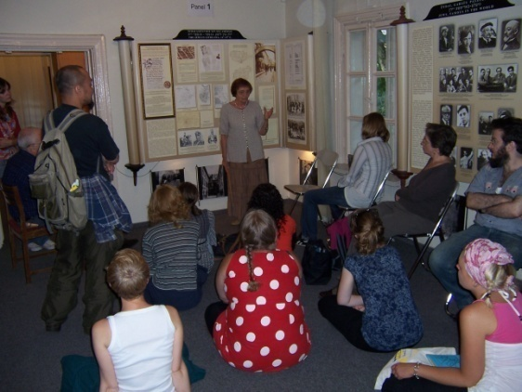
Work continued on research and collection of WW2 documental and visual material. In result the exhibition is enriched by new material: extracts from diaries written by Lithuanians to give their view on this topic such as the former University bibliographer and Righteous Ona Simaite, that of the right-wing Nationalist Party in Lithuania general secretary Zenonas Blynas, of the Archibishop of Lithuania Skvireckas. More documents are accumulated: various German and Lithuanian authorities’ humiliating decrees on Jews, their property and denial of any human rights

We compiled an expanded chronicle on the Vilna Ghetto, which we intend to print out as a brochure. We do the same about Kaunas. We plan to include data on the two other bigger ghettos in Wartime Lithuania – Siauliai and Svencionis, as well as a list of places of mass murder.

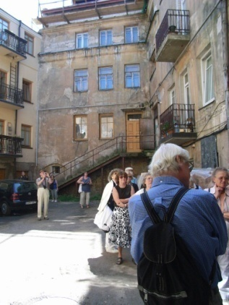
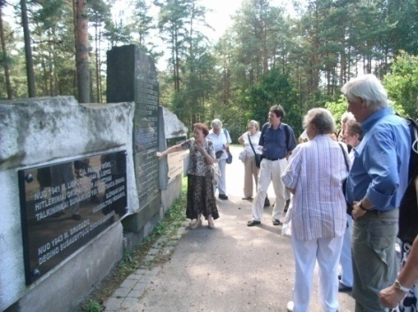
These documents deepen the knowledge of the main backgrounding war documents and reveal attitudes of various amplitudes from letters of great sorrow and sympathy to absolute neglect. The documents are translated into English, tantamount with other documents, as for example that of the wild scream of pain and sorrow about the rape of two little girls. The pages from a diary by K. Sakowicz written in Paneriai in presence of the open pits which devoured thousands of innocent Lithuanian citizens (Jews), etc. are among them. We are also working on visual-photo and video material accumulated party thanks to you, dear friends, sending us films, and other material. We have CD and photos and lack professionals to do the job.

Paneriai
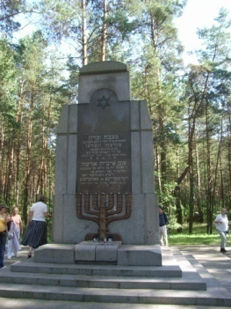
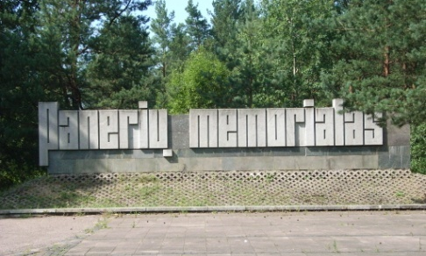
This museum branch located in the place and space, where the main extermination of the Jews in Vilnius and area took place in a 1941-1944 represents the biggest killing numbers around the Country. The Jewish Community (we are members of) often in cooperation with the highest Authorities of Lithuania and other organizations, organize commemoration of main events of the Holocaust in Lithuania. During September 2007 to August 2008, the number of groups visited Paneriai followed by guided tours was 252, the number of visitors was 10361. Besides that Paneriai receives quite a number of individual visitors. Among the mentioned are students from various schools.

History Department activities

The museum’s History department this year, as they do every year, carried out research activities. This year have been published:
- Jewish life in Lithuania (second edition proof by Jurijus Greismanas)
- Austria’s unique approach to cooperation in Holocaust research and education (the book was compiled by Jurijus Greismanas and Andreas Nöbauer, edited by Rachel Kostanian.

A number of articles were published by Judita Rozina, Ilona Murauskaite and Vilma Gradinskaite.

The department also worked on collecting material for following exhibitions:
- “Catastrophe” renovation (Galina Zirikova, Geoffrey Vasil, Rachel Kostanian, Ana Sosnovskaja, Neringa Latvyte)
- Exhibition “Paneriai” renovation (Algis Karosas and Jurijus Greismanas, Dalia Epsteinaite)
- The fate of Jewish children who were evacuated from Lithuania to Russia in 1941 (Tamara Omeljanciuk)
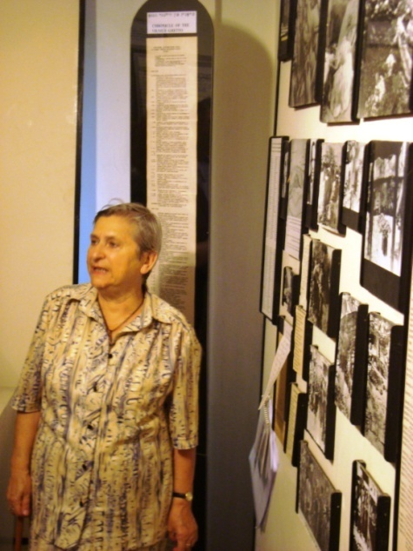
Department staff also participated in academic conferences:
- International Conference “Sefer (29-31 of January, 2008) where Ilona Muraskaite presented a paper “Problems of ‘Jung Vilne’ group”,
- At 14th World Congress of Jewish Studies with a paper “Jewish artists from Kaunas and their works during 1920-1940 exhibitions”. It was published in the Materials of the Congress. Author Vilma Gradinskaite

Department members took part in educational and academic activities, delivered lectures in schools and Jewish Community of Lithuania. So, Jurijus Greismanas, Ilona Murauskaite’s lectures “Dimitry Gelpernas – the hero of resistance in Kaunas Ghetto. His life and activities” and “Jung Vilne artists and writers group” were highly estimated by the Jewish Community members. Find more detailed information on Page 8 in Tasks and Accomplishments!
Fania Brantsovsky is giving a lecture in the museum of her own experiences in the Ghetto.
Our staff participated in a program on TV “Menora” with reports. A full list is additional given in the rubric Tasks and Accomplishments.

Work continued on topic Jewish education in inter-war Lithuania by department staff Judith Rozina, search for students from former Jewish educational institutions was carried out. Questionnaire information is being computerized and photographs would be used for exhibitions. Interviews with former students are being recorded as well. Work is also continuing on a chronicle of Jewish life in post war and contemporary Lithuania by J. Rozina.
In the department of
Rescue and the Righteous
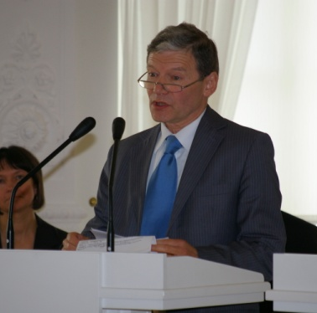
Work continues on the Righteous Gentiles project supported by writer Icchokas Meras, The search for rescuers and rescued continues, circumstances of rescue are being verified and the material in requisite form is being supplied to Yad Vashem in Jerusalem. During the first half of this year 10 Lithuanian citizens have been recognized as Righteous among the Nations due to the efforts of this project‘s working group.
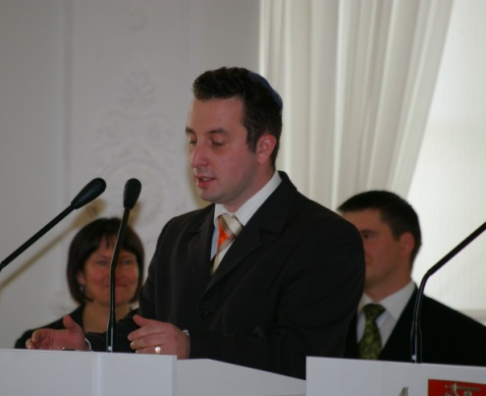
On the recommendation of the Jewish Rescue and Commemoration Department of our Museum, President of Lithuania Valdas Adamkus issued a decree number 1 K-1109 on September 12, 2007, awarding the Cross of Rescue of the Dying to 62 people, of whom 12 survived until that date, others, unfortunately, were awarded posthumously. Lady Margaret Kagan, a former inmate of the Kaunas ghetto who arrived from Great Britian especially for the ceremony, expressed gratitude to her rescuers and to all who were awarded with a sign of honor as Righteous Gentiles.
Museum director Markas Zingeris in his speech stressed that the Righteous Gentiles in saving Jews from Nazis took part in a silent spiritual resistance to dehumanization, racism and anti-Semitism. He expressed his gratitude to the survivors whose testimonies would for ages testify of the names and deeds of the Righteous Gentiles to stay in our consciousness.
The executive director of the Lithuanian Jewish Community, Simonas Gurevičius hold a warm speech to participants assembled in the White Hall of the Presidents Palace
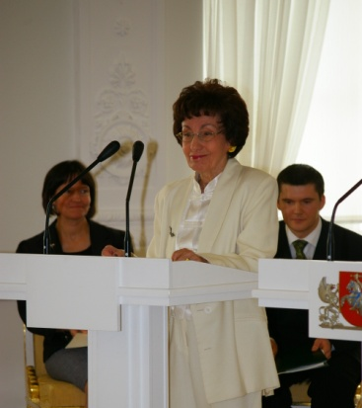
He underlined:
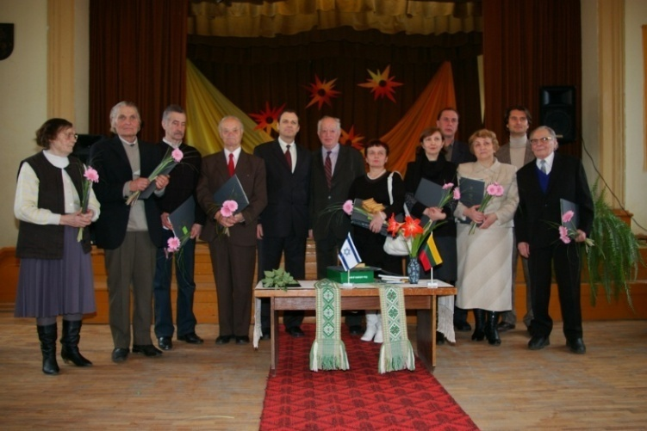
<...>Today there are people who deny the tragedies of the Second World War, and in so doing they are also trampling not only the memory of those who died innocently, but also the importance and nobility of your actions. We have to stop the denial of the truth because a nation that tramples history, forgetting its lessons, likely has no future <...>
The Jewish museum in cooperation with the Embassy of Israel, the Lithuanian Jewish Community and the International Commission for Assessing the Crimes of the Nazi and Soviet Occupational Regimes organized two Righteous of the Nations awards ceremonies in the first half of 2008: at the Užupis Gymnasium in Vilnius on
March 12 and at the Kaunas Town Hall on May 22. Programs for both awards ceremonies were prepared and the necessary information on 36 Righteous among the Nations awarded during these ceremonies was provided. That served as an example of human behavior and nobility in particular for the younger generation
Righetous among the Nations with Iraeli ambassador Chen Ivry and Lithuanian Jewish Community chairman Simonas Alperavičius after the awards ceremony.

Besides that the department staff worked on finalizing material for the new exhibition: “A rescued child speaks about the Shoa”, a big part of it had been transferred to the producer. Work on the book 4 continuing the series of books “Hands bring life and bread” is on the finish line. Meanwhile survivors’ memories have been recorded on video tape – those of Rescuers, Rescued, and all the places of hiding. So filming the story of Rescue of it members of the Kuklianski Family and their savior by three villages was recorded. The family came in 2006 and 2007 for that great historic record.
Information and publishing Department

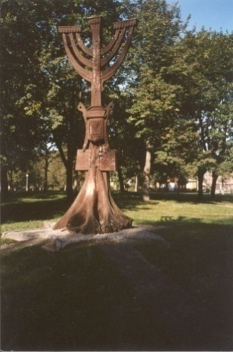
The department of information and publishing, led by Irina Guzenberg, accomplished work on publication of the third edition of the brochure “Vilnius: 100 Memorable Sites of Jewish History and Culture” The brochure was enlarged by additional historic information and photography (by eight pages).
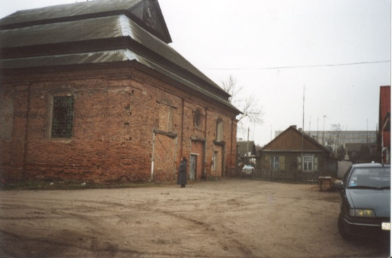
The department continues its work on three more books:
      - “The Ghettos of Oshmyany, Svir, Svencionys Regions: Lists of Prisoners. 1942”,
- “On the traces of Jerusalem of Lithuania”, guidebook
- “The Jewish theme in Lithuanian
Oshmyany Synagogue, erected in 19-th century. It was within the ghetto territory during the war.
Monument to the prisoners of Švenčionys ghetto
press” 1994-1995 (Bibliographical Index)

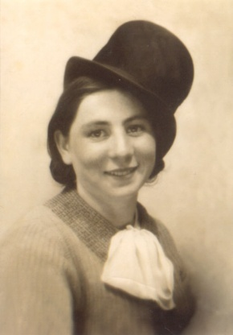
It is to be noted that the department staff continuously toil (since the ninetees) on research in the State and other Archives where until the early 90’s documentation on the Second World War was inaccessible. Based on that research (including quite a number of other sources) four books have already been published (in three languages: Lithuanian, Englsih and Russian). They are based on the lists of ghetto inmates (besides HKP), compiled in 1942 when a general census in Lithuania was accomplished. The books include not only lists of names and occupation, but contain scientific articles, memories and photo material. Much of this authentic material is published for the first time.
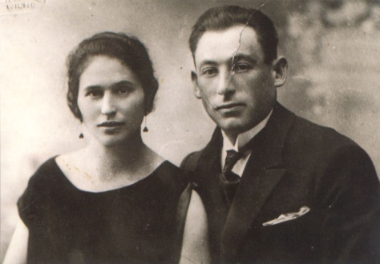
The lists of ghetto prisoners of Švenčionys, Oshmyany and Svir included in the publication are official documents, which reflect in greater detail who was in the ghettos of these regions in May, 1942, plus other information.

Illustratrations in this book contain photographs from various sources like the museum’s and other archives, from personal collections as well as pictures shot especially for this book.
Genia Gordon, Moishe‘s sister,
perished during the war
Basia and Moishe Gordon. Prisoners of the Švenčionys Ghetto, perished during the war.
The publication is preceded by an article of historian Arūnas Bubnys, Ph D on the fate of the Jews in Švenčionys, Oshmyany and Svir regions between 1941 and 1943.
As for the bibliographical index – it contains essential information for those interested in a broad picture of contemporary life of the Jews in Lithuania today and in the past as well as local attitudes to that topic. We have already published 3 books but are not sure about the next.

The Tolerance Centre
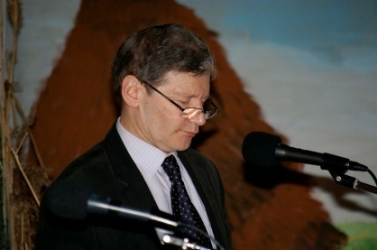
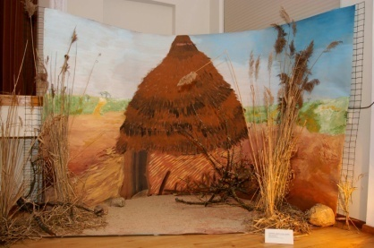
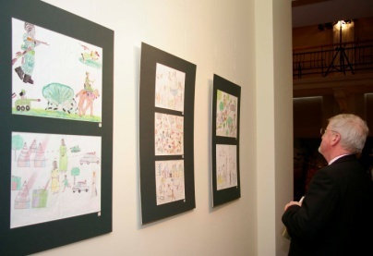
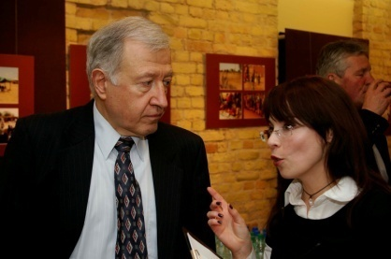
Located in the former Jewish theater, our Centre of Tolerance is the venue for many events associated with Jewish life and history. It is visited by children and adults and provides guided tours, host conferences and exhibitions.
Mr. Markas Zingeris Director of Vilna Gaon Jewish State Museum
Mr. Donal Denham, Ambassador of Ireland, looking at the drawings
Installation “The Darfur village” made by Vilnius Zverynas High School
Abassador of Bulgaria Mr. Ivan Dantchev and Head of the Tolerance Centre Ieva Sadzeviciene

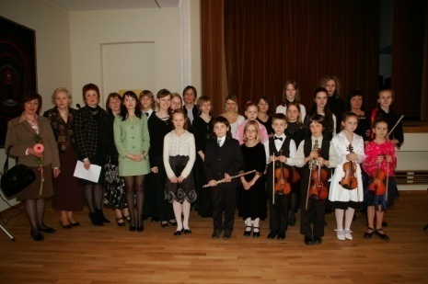
Exhibitions in the Tolerance Centre
“Drawings. Three cycles” (2008 01 09 – 02 25) –exhibition of art works of the Jewish – Lithuanian artist Adasa Skliutauskaite based on her illustrations to G.Kanovicius’ book “Candles in the Wind”: acquired to the permanent collections of the Vilna Gaon Jewish State Museum.
Exhibition dedicated to the 60th anniversary of the known architect Leonidas Merkinas (2008 02 29 – 03 17) - the renovator of the Tolerance Centre building, organized by the Centre and the architect.
Celebration of Pesach in the TC at the opening of an event
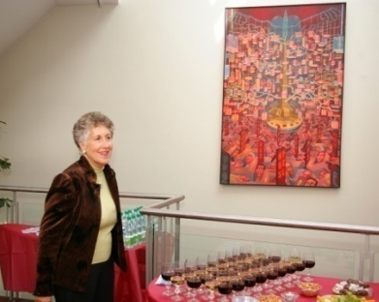
“Genocide Children: A Look at the Sudan of Today” (2008 03 19 – 04 11) – the exhibition presented drawings made by children from the Sudanese region Darfur. A round table debate was held at the opening of the exhibition. This event was dedicated to the European Week Against Racism (15 – 23 March, 2008). Organized by the Centre, Waging Peace (United Kingdom) and The International Historical Commission.
“Pesach – “Jewish Easter” (2008 04 20 – 05 11) – the exhibition presented drawings and the quilt made by children from the Solel Congregation Jewish School (Illinois, USA), dedicated to the Jewish festivity of Pesach. This exhibition will travel through Lithuanian schools, teaching Lithuanian children about the Jewish traditions.
“Israel. Light Touch” (2008 05 13 – 06 05) – the exhibition, dedicated to the 60th anniversary of the establishment of the State of Israel, shows this country through the eyes of the Lithuanian and Latvian photographers. Organized by the Israel Embassy to Lithuania and Latvia, “FotoForma” (Latvia) and Centre.
Susan Carson at the Presentation of the Golden Calf
“Once Upon a Time in Lithuania” (2008 06 12 – 07 09) –exhibition of drawings and paintings of Jewish-British artist Naomi Alexander, depicts the remnants of the past Jewish heritage in Lithuania. The painter, a Litvak, spent two years in Lithuania, tracing her ancestors’ ways.
“Spilt Identity” (2008 07 17 – 09 10) – Author of exhibition paintings and photographs is Jewish-Austrian-British artist Sandra Brandeis Crawford. Organized by the Centre, the Embassy of the Republic of Austria and the British Embassy.
Conferences, concerts, lectures, presentations, seminars and meetings
The presentation of the museum’s academic book “Vilna Ghetto Posters”, took place on September 20th, 2007; The audience qualified the book as a unique creation. Compiled by Eugenija Biber, Judith Rosina and Rachel Kostanian.
Lectures for schoolchildren: “Jewish life in Lithuania. The fate of Jews from the Shtetl of Jurbarkas in Lithuania” and “Nazi crimes during the war”, October 12th, 2007;
“The Pattern of Traditional Jewish Life and It’s modern transformations” – lector Dr. Larisa Lempertiene, Vilnius University, November 6th, 2007;
Presentation of the French writer’s Odile Suganas book “The Mosaic of Memory”, was organized by the museums history department and the Centre, December 12th, 2007;

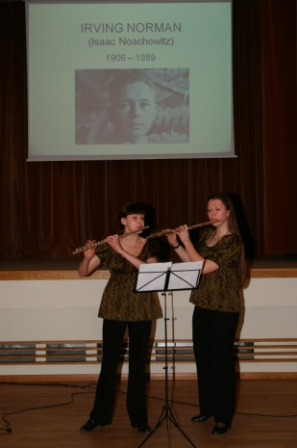
Commemoration of the International Holocaust Remembrance Day was marked by a presentation of the documentary film “Sugihara: Conspiracy of Kindness”. The event was organized by the Centre of Tolerance and the American Centre of the USA Embassy, January 27th, 2008.
The official unveiling of the famous Vilnius-born USA artist Irving Norman’s painting “The golden Calf” (1985) took place on April 9th. It was a gift to our Museum by artist’s wife Ms. Helena Norman. During the ceremony a lecture about Irving Norman’s life and his oeuvre was presented by our art historian Dr. Vilma Gradinskaite.
“Songs of Remembrance” The Catastrophe Remembrance Day – a classical music concert - took place on April 29. Music of Johannes Brahms, Robert Schumann, Viktor Ulman and Lori Laitmain, to texts by known poet Abraham Sutzkever, were performed.
The unveiling of the Golden Calf

An international seminar “Jewish Education Traditions in Europe”, was organized by JETE, The Education Centre of Telsiai and our museum’s, Centre June 19th, 2008.

Tasks and Accomplishments

Publications
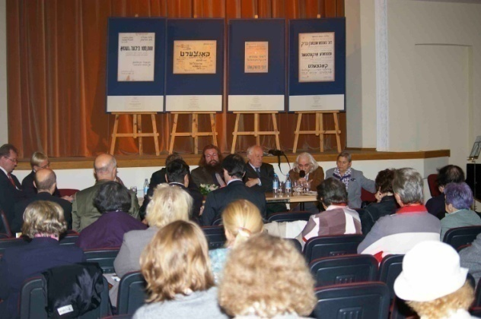
- “Jewish Life in Lithuania. Exhibition Catalogue.” 2nd edition. Vilnius, printed by publishing house “Zara”, 2007, 221p. Lithuanian and English. Curator of the exhibition and publishing organizer was Ruta Puishyte.
- Austria’s unique approach to cooperation in Holocaust research. Compiled by Jurijus Greismanas and Andreas Nöbauer, editor Rachel Kostanian, Vilnius, printed by publishing house “Zara”, 2008, 72p, English
- 100 memorable Sites of Jewish History and Culture, third edition, compiled by Genrih Agranovskis and Irina Guzenberg, Vilnius, printed by publishing house “Darlis”, Vilnius, 2008, 64p, Engli sh
Presentation of „Vilna Ghetto Posters“
- Museum special yearly publication Newsletter Nr. 11, September 14th, 2007
Articles published
Judita Rozina, how the book “Vilna Ghetto Posters” was created, Newsletter 11, September 14th 2007
Ilona Murauskaite, in lith. Newspaper “Lietuvos Jeruzale”, December 24, 2007, “Chemist’s Joshua Melnik 100 years anniversary”
Vilma Gradinskaie “Paintings of Jewish artists from Kaunas. Exhibitions of 1920-1940.” Proceedings of the 14th World Congress of Jewish studies, 2007, pp. 125-136
Ieva Sadzeviciene “Israel – Sensitive touch”, Photoexhibition – www.alfa.lt, May 15, 2008
Ilona Murauskaite, “Jung Vilne”, group of young Jewish writers and artists. Newspaper “Lietuvos Jeruzale”, March 15, 2008
Participation in TV and radio programs
Dalija Epsteinaite presented to program Menora on Lithuanian Radio two topics
- “Doctor Shabad. His life and activity”, Ocotober 5, 2007. The doctor was an academic and known and leading public figure, active in all spheres of life. He was elected to the Russian Duma and later to the polish Seijm.
- “Odile Sugan – the family hearth keeper”. December 15, 2007. The life story of a French writer with family’s roots in Lithuania. Her uncle, Dovid Umru was the prewar director of Jewish Theatre.
Lectures
Dalia Epsteinaite “Nazi crimes in Lithuania. The fate of Jews – residents of Lithuanian shtetl Jurbarkas.” October 12, 2007.
Dalija Epsteinaite delivered a lecture to a school in Butrimonys “The fate of shtetl Butrimonys Jews”, December 14, 2007
Jurijus Greismanas, “Dimitry Gelpernas – the hero of resistance in Kaunas Ghetto. His life and activity”, at the Jewish Community of Lithuania, March 15, 2008
Ilona Murauskaite, “Group Jung Vilne activity” at the Jewish Community of Lithuania, February 10, 2008
Vilma Gradinskaite introduced the painting “The Golden Calf” of artist Irving Norman (US), whose wife donated this picture to the Jewish Museum. March 9, 2008
Vilma Gradinskaite “Children in Jewish artists’ pictures” Jewish Community on May 25, 2008.
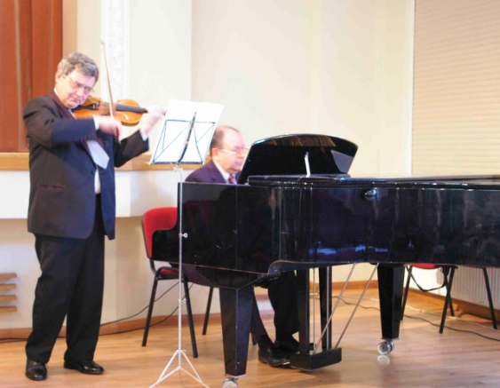
Vilma Gradinskaite “The shtetl in Jewish artist’s art” at Vilnius Yiddish Institute, August 20, 2008
Three lectures were delivered by Rachel Kostanian at the Jewish Institute of Culture “Spiro Arc”, 1. Holocaust in Lithuania; 2. Spiritual Resistance in the Vilna Ghetto; 3. Everyday life in the ghetto. London, October 2007 by Rachel Kostanian
Seminars
Daiva Osipovaite took part in an international youth project “Love your neighbor as yourself”. October 8-14, Israel.
Aiste Niunkaite – Raciuniene participated in a seminar “Audiovisual means for exhibitions”, October 18, 2007, Vilnius.
Ieva Sadzeviciene took part in seminar “Audiovisual practice – How to acquire rights” April 17, 2008, Switzerland.
New Books

Published in 2007 and 2008

Vilnius: 100 Memorable Sites of Jewish History and Culture
Irina Guzenberg and Genrich Agranovski

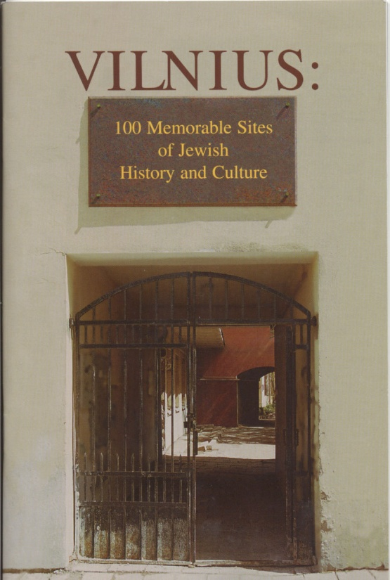
Right now in 2008 we have published the third edition of “Vilnius: 100 Memorable Sites of Jewish History and Culture” – as the second edition of 2007 brochure was sold out. The purpose of this guide book is to allow everyone visiting Vilnius or interested in to become acquainted with its many significant sites of Jewish history and culture. For the sake of convenience, the list of memorable sites has been divided into four sections: Remembering the Past, the Catastrophe, Jewish Cemeteries and the Present Day. This edition was enlarged by new historical information on knows Jewish public figures like Dr. Tsemach Szabad (world famous writer), Romen Gari and includes more historic information.

Vilnius, Vilnia, Vilno, Vilna, Vilne – so the capital of Lithuania
was called by its various, often multilingual inhabitants.
But there was yet another name for Vilnius – Jerusalem of Lithuania. It was the Vilnius Jewish community that became the major intellectual centre for all Eastern Europe Jewry from the eighteenth century on. Its hundreds of synagogues and study houses were filled with young students and elderly Jews studying Torah and Talmud. In its narrow urban quarters, Jewish life pulsated with yeshivas, schools, libraries, publishing houses, shops and street peddlers. In later years, there were theatre, music, art and literary societies, libraries and publishing houses, not speaking of high level schools, Zionist groups, Yiddishist groups, political parties of every stripe and workers unions. But probably as main achievement was the 1925 creation of YIVO – the Yiddish scientific Institute, continuing now in New York. All about its is to be found in our new book.
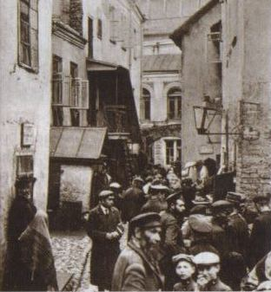
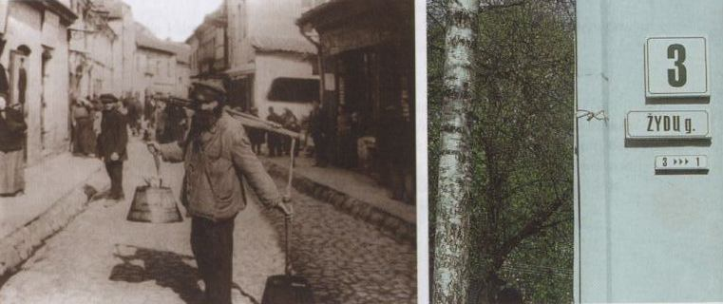

Jewish life in Lithuania
14-20 Century
New Books
Second Edititon

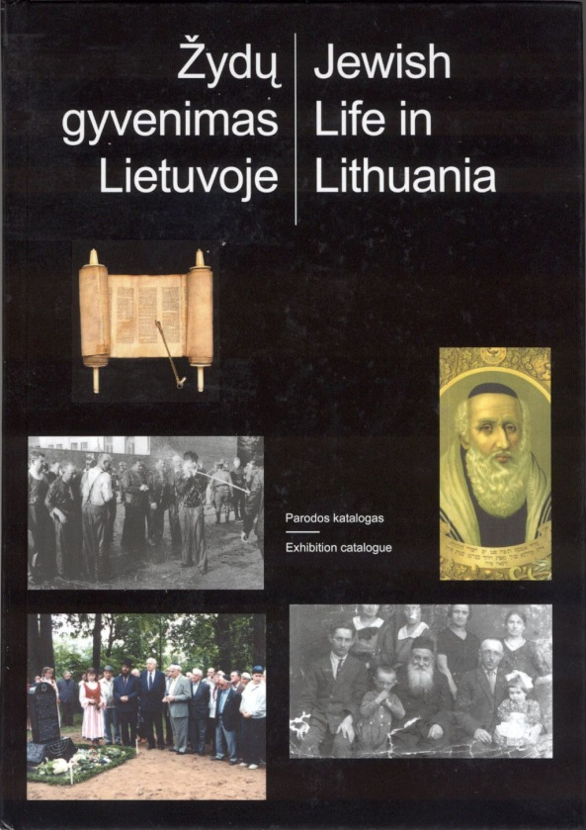
The book “Jewish Life in Lithuania” is intended to serve as a catalogue for the permanent and travelling exhibition with the same name. The book has become much more than an exhibition catalogue: most readers regard the catalogue as a book full of new information, designed in an attractive way. The book meanwhile, can now be found, besides our museum branches, in libraries, universities, schools and private households across Lithuania and abroad.

The main goals of the exhibition and the publication are to tell the history of Lithuanian Jewry and the influence that Jews have had in Lithuanian society – some of these influences still remain. Of about 220,000 Jews that lived in Lithuania, only 6% survived the Holocaust. With these people, a stunning Litvak civilization also disappeared.
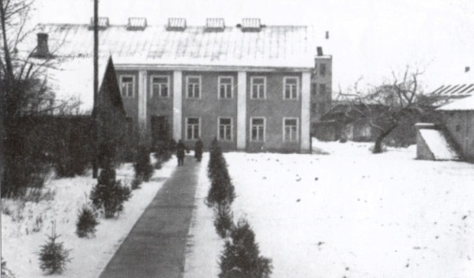

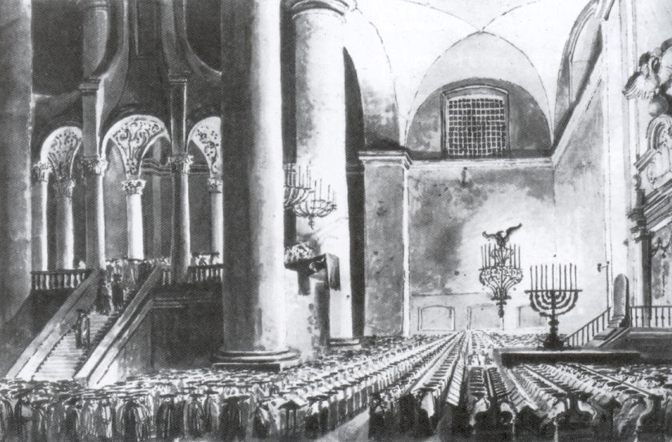

The building of the YIVO (Institute for Jewish Research)

Jews have made major contributions to world culture in the arts, science and crafts.

The Vilna Great Synagogue stood at the heart of the Jewish Quarter.
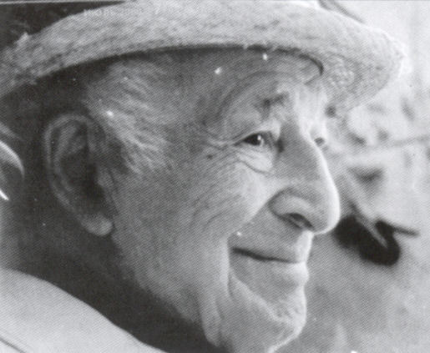

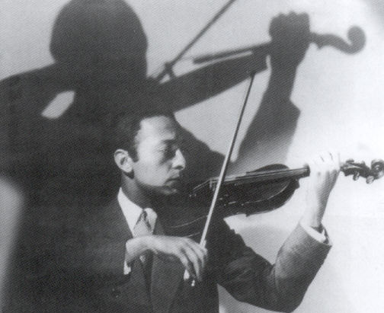

The Painter Marc Chagall
The Violinist Yascha Heifetz

Austria’s unique approach to cooperation in
Holocaust Research and education
New Books
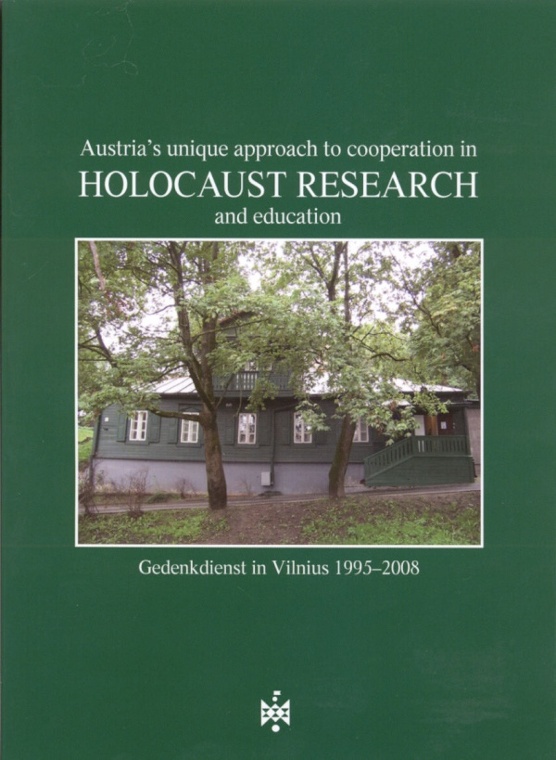
Gedenkdienst was founded in 1992 in Austria. Since the establishment of this great memorial service, approximately 200 Austrian young men, as an alternative to doing army service, have completed their Gedenkdienst work at various Holocaust institutions, memorials and research facilities. Among them Theresienstadt, Yad Vashem and the Anne Frank House as well as retirement homes for victims of the Nazi. It is quite fortunate for us that they come to work at Jewish museums, including the Vilna Gaon Jewish State Museum in Lithuania.
From the foundation of Gedenkdienst to 2008, twelve volunteers from Austria have worked 14 months each in our Museum. To celebrate the 10-year anniversary of the volunteers’ work in Vilnius, the museum, full of gratitude to “our guys,” decided to organize a reunion in the format of a symposium. This endeavor was warmly met and received by the then Austrian Ambassador to Lithuania, Dr. Michael Schwarzinger. The idea was supported by Anne Frank House, the Gedenkdienst organization and Ruta Puisyte from the Vilnius Yiddish Institute. The ambassador’s help was indispensible.

The today Ambassador of Austria, Mrs. Wicke kindly took over the project of publishing this brochure and became very interested in it

Each and every volunteer not only performed his work, but did so with great enthusiasm. It was a serious task to arrange work arranging bringing the Anne Frank exhibit to Vilnius, participate in creating an exhibition Jewish Life in Lithuania and or participate in the Vilnius Ghetto posters exhibit. It was even more challenging to travel with the exhibitions to schools all over Lithuania, holding seminars with heated discussions.

Another challenge was compiling pamphlets and the annual museum newsletter (typing all the texts, doing the layout, collecting and selecting the material). Our volunteers participated recording historical events in Lithuania during in interviews with survivors, producing films of their own chioce, helping to create the beautiful catalogue for the “Jewish Life in Lithuania” exhibit, translating into German the museum’s book “Spiritual Resistance in the Vilna Ghetto,” performing over 50 lecture-seminars in schools around Lithuania. Their work has also been an educational one when guiding visitors around the exhibition in the Katastrophe museum branche and in the former ghetto, they also help perform office work. During the Reunion our guys said they had a tremendous experience and that the year had changed their lives. Their letters up to now confirm that. We became a Family.
The museum is very grateful to all the volunteers and to the organization which was able to select, teach and send such wonderful young people to Lithuania.
The Gedenkdienst organization and the volunteers serve history, education and tolerance.
Presentation of Vilna Ghetto Posters in London

On 11 November 2007 the travel-exhibition “Posters of The Vilnius Ghetto” in the Spiro Ark Institute of Jewish culture in London was opened.
These posters were produced by Jews interned in the Vilnius Ghetto announcing cultural and social events which they had created to keep their spirits up while physical conditions were unbearable. During the first week of the exhibition museum’s deputy director Rachel Kostanian hold a number of lectures:
- Spiritual Resistance in the Vilnius Ghetto
- Life, death and collaboration in the Vilnius Ghetto
- Paneriai – representation + film about local memory of neighbors, filmed in Ponar by Israeli film makers.

The exhibition was shown for 4 weeks. It was organized by the London Institute in collaboration with the Lithuanian Embassy in London and our Museum in Vilnius.

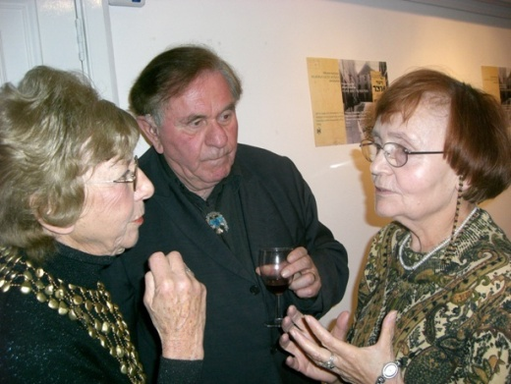
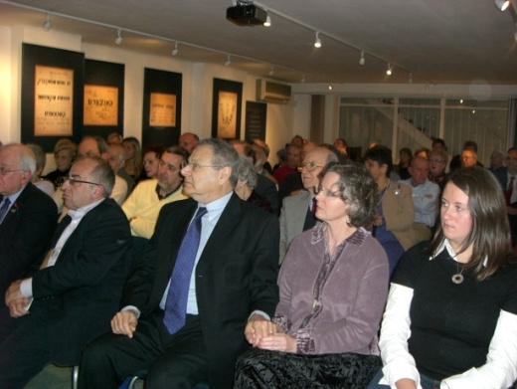
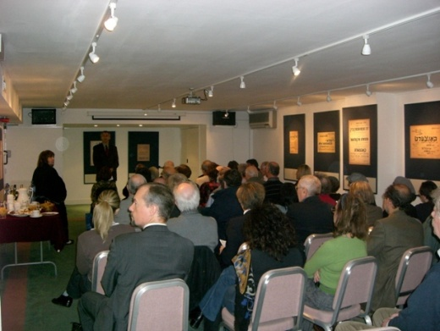
In the middle: Sir Martin Gilbert
Discussions after the lecture
Opening speech of Ambassador of Lithuania

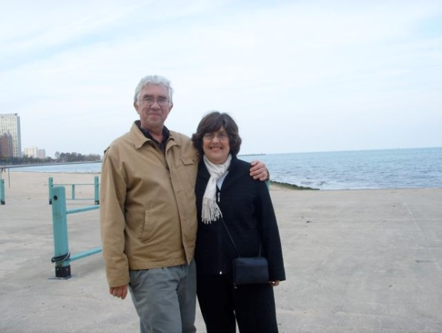

We express our deep condolences to Ms Southhard who lost her husband Prof. Robert Southhard. They visited us a couple of years ago and had become good friends, impressed by museum staff work..

Statistics
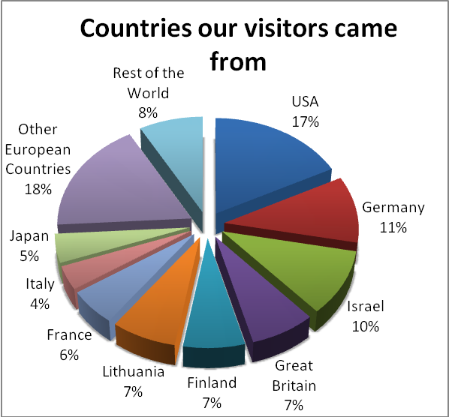
In this years’ newsletter we also present statistics on our visitors. These are based on register made by our staff at the Holocaust exhibition, at the branches of the museum in Ponar, at Pylimo 4 and Naugarduko 10/2 – the Tolerance Centre.

In spite of the general decline of visitors to Lithuania between September of 2007 and August of 2008, more than 21,561 people from more than 40 different countries visited the main branches of the museum, a significant increase over last year. The Green House, or Holocaust Exhibition, welcomed 4,021 people according to the log book. The branch at Pylimo 4 saw 1,400 visitors and the Tolerance Centre met 2,935 visitors according to statistics kept there. The small museum at the mass killing site of Ponar (Paneriai) south of Vilnius reported 13,205 visitors over the course of the year. We couldn’t include figures of visits by countries of origin from Ponar, Pylimo 4 or the Tolerance Centre in our chart, so this chart only documents visitors to the Holocaust Exhibition at Pamėnkalnio 12 in Vilnius.

The biggest group in the Green House was a group from Italy with 84 people and in December we had also a big guided tour for disabled persons. We had a guided tour for the Embassy of the United States and the Embassy of Austria at the Holocaust Exhibition as well as representatives from the US Congress, and Ms. Ruth Lande, the Advisor to the Israeli President Shimon Peres. Many diplomats visited our Tolerance Centre, including all main Embassies.

Looking at the distribution of visitors by home country, we found that 59% come from countries of the European Union and 49% from other countries. We have an increase of visitors coming from France, Italy, Israel and Japan and a decrease of visitors coming from Germany and the United States.
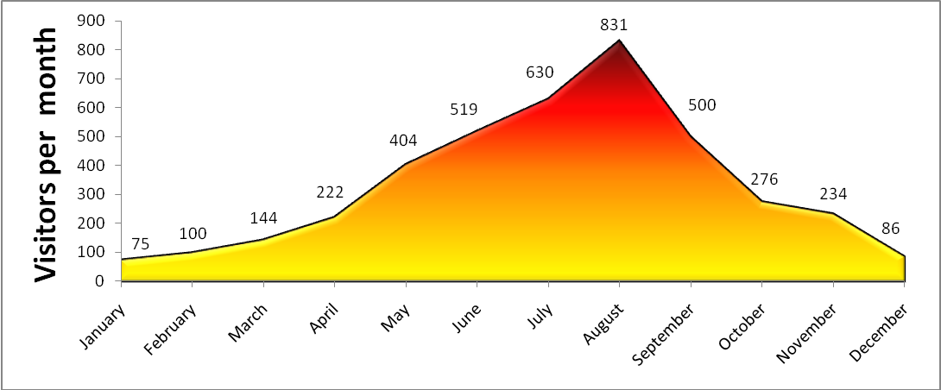
Among foreign media and letters

The New York Times published (July 16, 2008) an article by Ms Lynnsdop about Vilnius and Lithuania where our museum and the Green House is marked twice for giving answers to who the Litvaks were and to how the Jewish Community here was wiped out.
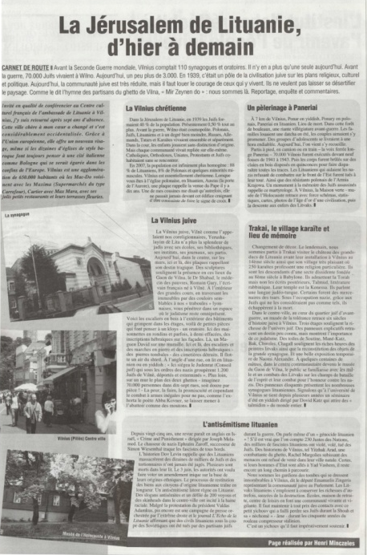
The Vilna Gaon Jewish State Museum (three locations; www.jmuseum.lt) provided some answers. Litvaks, as the Jewish Lithuanians were known, were traditionalists, seeking truth in the Torah and resisting assimilation, but many also joined the Haskala, or Jewish Enlightenment, and made significant marks as scientists, academics and artists. Between the wars, an art scene flourished, and many of the paintings and woodcuts from the so-called “Lost World” are on display at the museum’s Centre of Tolerance (10/2 Naugarduko Street).
The museum’s Green House (12 Pamenkalnio Street) also shows quite graphically how 90 to 95 percent of Lithuania’s 250,000 Jews were murdered. The Nazis invaded in June 1941 and in July, often aided by Lithuanian collaborators, began an organized slaughter of Jews, communists and the mentally ill. One chilling German document lists the number of people killed, day by day, village by village, sweeping across Lithuania from west to east.
New York Times, July 16, 2008

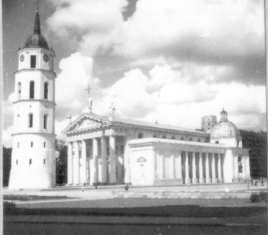
A couple of days ago we got a letter from Gudo Mattiat we want to share with you:
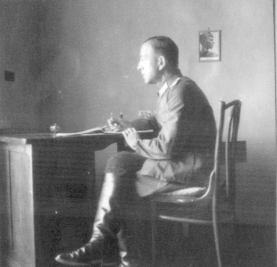
“Wilna: Kathedrale” –
Vilnius: Cathedral
“I’m 67 years old and the youngest child of prominent Nazi-family from Göttingen. Only at the age of 19, I have denazified myself thoroughly and sustainably. Now I know that my father, Eugen Mattiat(1901-1976), was lieutenant in the years 1941 to 1943 but above all he was stationed as “Hauptsturmführer der Waffen SS” in Wilna.
My father was pastor, religious Christian. I know him as a naïve, weak, but idealistic, beddable Person. I can’t imagine that he ever hurt somebody.
On the other hand I can, especially after reading the book by Mascha Rolnikaite not imagine that someone who is so exposed as an officer of the Wehrmacht and Waffen SS, stationed in Vilnius, wasn’t involved in these terrible events. This question frets me very much! […] Could you advise me which archive could help me to find out about the activities of my father in Vilnius? […]I thank you, on behalf of my wife and my children, for your great commitment against forgetting”

“Im Quartier” – In the billet
We thank you, dear, for what you feel, for your broken heart. Yes, the Catastrophe of Jews was not only theirs; it was also disastrous to Germany and other countries.
We got quiet a number of photos taken by Gudo’s father in Vilnius 1941-1943 and publish here two of them.

The majority of our visitors are very appreciative of the museum’s work. Among letters we get from the young volunteers from Austria we want to share with you a part from one letter written by Alex Gruber:

First of all I want to apologize, that it took such a long time, that I didn’t haven’t written to you. But this spring was really, really busy. […] We organized two conferences. The first one was a local one, where different scholars from Vienna – including myself – were giving lectures. From that conference emerged a book, we published in March. […] the second conference was even an international one with scholars from Germany, Portugal, the United States and Israel – probably you know Benny Morris and Yossi Melman. It were very good conferences but all coverage we got in the media was that we were war-mongers – and this just because we said that it is Israel’s right to defend herself against the threat that Iran imposes. […] Besides these actions I also have been working at the Vienna University since last September. I am giving lectures and Political theory there and it’s a really nice job. […] Besides that I still work half-time at the “Nationalfond” and I became a museum’s guide again. At the moment I am giving guided tours to pupils at an exhibition called “Boarding Pass to Paradise”. […] I really hope that I will be able to make it to Vilnius in the near future to visit all of you again. When I read about all these horrible things that are going on with Fania I once again realized how close I still am to Vilnius and to all of you. You became part of my life and you will be forever.
So give all my best wishes to everybody of the museum’s family.
Alex Gruber
To our Friends abroad

In addition we would like to say a couple of words to some people who in spite of their physical absence here are inscribed in our hearts.
To Mr. Samuel Back
It is our great honor to congratulate you, known Artist, with the tremendous success of our exhibition in Jerusalem. We are happy you are the museum’s friend
To Mr. Tseytlin
Dear Yevsey, we sincerely congratulate you, our former irreplaceable staff member and writer, with the 30 Anniversary of the known newspaper “Shalom” where you toil diligently and painstakingly as you did in our museum. We are sure that you contributed to its success largely. We wish you to continue for dozens of years and you know - we miss you, Yevsey!
To Rachel Margolis
Dear Rachel, we, those who worked close with you express our deep disappointment and anger that you cannot come this year because of known circumstances.. You had to cancel your ticket and many students who come to the Yiddish Institute and visitors to our museum are denied the unique possibility to listen to your full of authentic knowledge and wit lectures about Vilna, your native city, the cradle of spiritual scholarship , and about the war. We hope to see you soon, we believe that! Zai gezunt!
We commemorate the birthday on August 12 of our beloved leader of the Rescuers Dpt. Michael Erenburg. Let his memory stay in Peace.
The lack of space does not allow us to address everyone dear Friend.

Visitors & Friends

Comments by our visitors
Every year hundreds of visitors from all over the world come to visit our museum. Among them are survivors of the Holocaust, Litvaks, tourists, students and well-known personalities with political, scientific and cultural backgrounds. Here we include a few entries from our guest book from September 2007- September 2008:
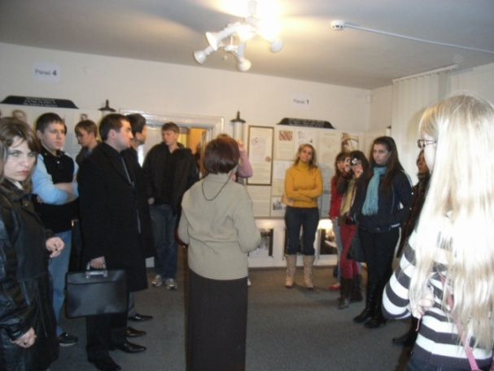
Many thanks for this essential museum and providing such a moving exhibition of this time in history. […] This museum is an wonderful achievement.
Stephanie Sewin, USA, January 21, 2008

This museum is very important and everyone should come here to learn the truth about Jewish history in Lithuania. What a tremendous achievement to have this place.
Kelsey Bakos, USA, January 21, 2008

It is an education for us, so many things we are ignorant of. It is a very good Museum for all these records of the great suffering of your brave people.
Mr. & Mrs. Needs,UK, August 25, 2008

It seems impossible that humans can be so inhuman. That men can hate other men in that way and kill them in the way they did with Jews. This is a great museum that shows what should not happen again. Ignorance and prejudices are the beginning of all these horrible facts and we have to face it. Unfortunately we found similar horrors in our days. Half a century later the world still sees similar attacks against humanity.
Thanks to enjoy the museum very much
Ouna, Spain, August 12, 2008

Long live the memories, melodies and numberless contributions that came from Lithuania – changed the face of the Jewish people. We will never forget! Thank you for bringing the story to life for us and thereby honouring the memories of the murdered.
Mikal Matter, Israel, August 07, 2008
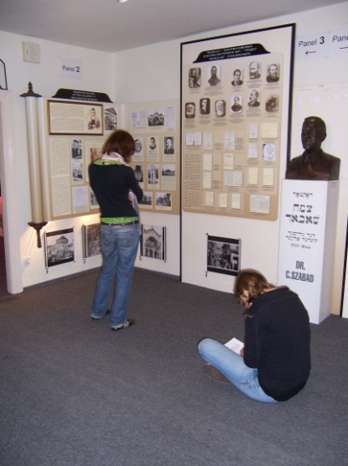
The museum was very depressing – I am speechless. But it was very interesting. There is a lot that I previously didn’t know about – The Jewish Community in Vilnius, the extermination of Jews outside of the Concentration Camps. It is still unbelievable that things like this actually happened. May they never happen again.
Kristi Zychoukan, Canada, May 21, 2008

I am honoured to be perceived by you as one of the members of the museum.
Samuel Bak, July 09, 2008

A very impressive museum – It’s a duty to remember and not forget.
Bein Miriam and Nehema, Israel, June 22, 2008

Comments by our visitors, continued:

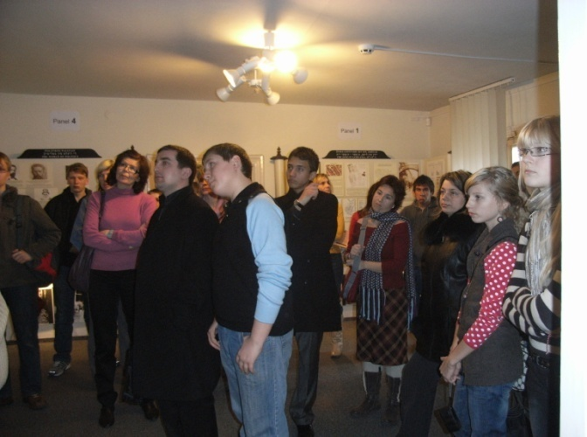
This is an immeasurable treasure of significant value! I cannot begin to think the amount of work invested in the compilation of the research of information and the documentation/photos/posters. I strongly believe that protection our heritage is a value we must strive to preserve, as it constitutes an important component of our identity as a People, the Jewish People.
Tova Ben-Dov, Chairperson, World WIZO Executive, by email, April 29, 2008
[in connection with our book Vilna Ghetto Posters]

This is not my first time in this amazing museum which gave me a very substantial, authentic, concentrated information about the Jewish community, culture and its tragic catastrophe.
The visit of the museum with the guidance of Rachel was absolutely one of the high points of my visit and I hope that the Jewish Community and the Lithuanian Culture Department will cherish this place, which surves as a living document of a lost time. Thank you
Tsila Zak, Israel 25. April 2008

Thank you for the work you do. It is because of places like this that the world has hope for the future of Tolerance and understanding. By teaching what you do, there is hope that the Horror done to our people will not be forgotten and the future will be brighter than this dark past.
Phil Ainger, Canada, April 12, 2008

I do not have words to express my feeling for the victims and their families. May God bless all of them. The museum is a great place to get to know about what exactly had happened to the innocent Jews in Lithuania and particularly in Vilnius. […} It has been wonderful experience but a very sad one. I was so touched by the exhibition in the room 7. My wishes and love to all the victims and their families.
Asia, June 30, 2008

The museum seems to have grown beyond recognition since I first saw its beginnings in 1993. The very best of luck. You've all done a wonderful job.
Rose Wolf, per email, July 17, 2008

While travelling in Lithuania this summer with the only purpose to visit the remains of Jewish heritage, my wife & me visited Vilnius. We visited the Jewish museum’s exhibition. We were kindly treated by Mrs. Tamara Omeljancuk, who performed for us the unforgettable excursion in Vilnius Ghetto, presenting us not only the facts about is, but also the atmosphere of Jewish life, sufferings and heroism. Besides that, while visiting the Jewish museum with it’s rich collection of artefacts we bought the autobiographical book by Mrs. Margolis. We can’t mention other book, devoted to Shoah, which would be written in such attractive manner and so true.
Dr. Kechker Michael & Irena 19.December 2007

May all your efforts help that this one of the darkest periods of humanity – may never be forgotten.
Andrea Wicke, Austrian Ambassador, June 17, 2008

Although there is great sadness in the history told here, there is also hope as shown by those who hid and saved their neighbours.
Yette Batas, Australia, August 04,2008

Thank you for the work you do. It is because of places like this that the world has hope for a future of Tolerance and understanding. By teaching what you do, there is hope that the horrors done to our people will not be forgotten and the future will be brighter than this dark past. In Peace,
Chiel Boeron, USA, July 30,2008

Friends & Supporters

We’d like to thank all our dear friends who have supported us so generously. Thanks to you we are able to continue our work.

In 2007-2008 (5768) the museum received many warm letters and gifts from supporters around the world. The following people and organizations donated books, compact discs, DVDs, magazines, academic journals, photographs and other materials, but the list is only a partial one so apologies to anyone left out, your support is much appreciated even if your name didn’t make it onto this list.

W. Brockjan (Germany), Philip S. Shapiro (USA), Mira Jedwabnik (USA), Wyman Brent (USA), Somas Dovidovic (Lithuania(, Bernard Aptaker (USA), The Library of Congress (USA), Zemaiciu muziejus “ALKA” (Lithuania), Hidden Child Foundation (USA), Jewish Community St. Petersburg (Russia), Rolnikaite (Russia), Oxford University Press (USA), Professor Colin Tatz (Australia), Sir Martin Gilbert (UK), M. Rosenblum (Israel), London Jewish Cultural Centre (UK),Redakcija “Dosjidisze Wort” (Poland), Yad Vashem (Israel), Ilana Tahan (UK), Renaissance Publishing Ltd (UK), Theodore Smith (USA), Vincas Kibirkstis (Lithuania), V. Kostantinov (Israel), Henrikas Klementavicius (Lithuania), USHMM

Financial Supporters

Keith Kaye via the American Fund (USA), Karen Smith (UK), Janine Cohen (USA), Carol Kaplan (USA), Leona Z. Rosenberg (USA), American fund for Lithuanian and Latvian Jews Association, Dan and Phil Shapiro (USA), Gordon Schochet (USA), Deborah Allen (USA), Morion Dowling (USA), Anthony Schneider (USA), Samuel Josefowitz (CH), Oscar H. Schachter (USA), Edward Cowan (USA, Carl Barron (USA), Anna Kremer (Canada), Neil Corwin (USA), American Fund (USA),
Newsletter publikuojamas kasmet žydų naujųjų metų Roš haŠana proga ir išsiunčiamas Vilniaus Gaono Valstybinio Žydų muziejaus remėjams, diplomatams, interesantams, muziejams ir draugams. Publikacijos paskirtis yra dvejopa—proga pasisveikinti su Naujaisiais metais, šimet 5768 pagal žydų kalendorių, ir taip pat atisikaityti apie muziejaus metinę veiklą tiems, kurie palaiko Vilniaus Gaono Valstybinį Žydų muziejų arba kitaip remia savo darbais, dovanomis ar žodžiais.



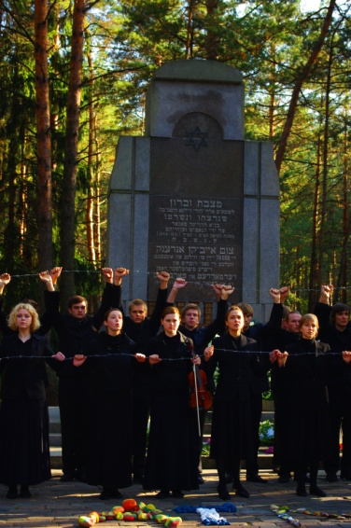
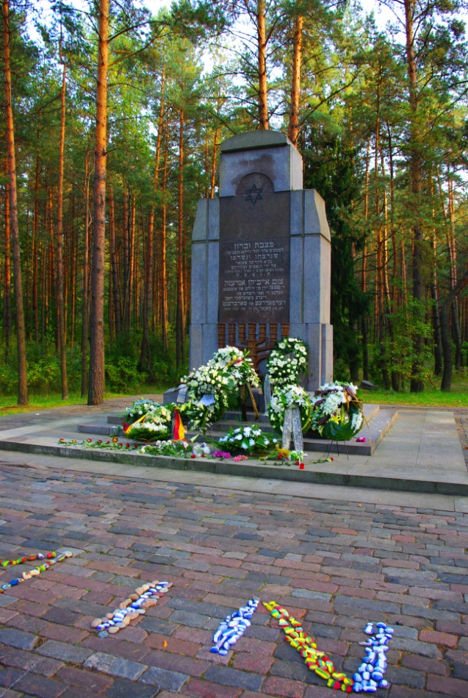
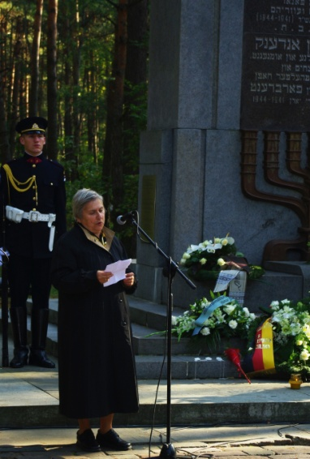
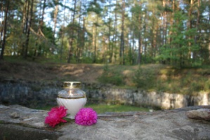
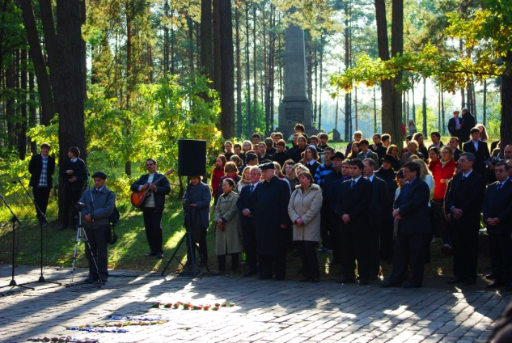
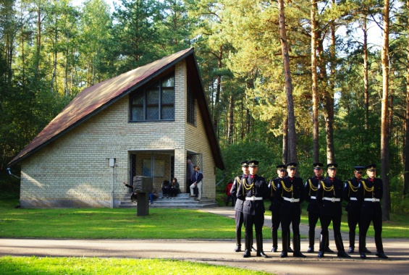
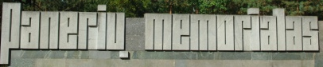
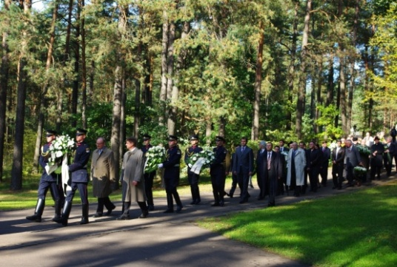
Day of Genocide of Lithuanian Jews
23rd September 2008

